2019 People-to- People Exchange
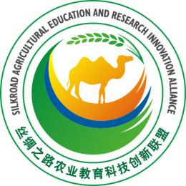
Summer program schedule
（Nov. 10– 19）Tentative

Date | TIME | EVENT | VENUE
11/10 (Sun) | 08:00/23:00 | Pick up & Return to Yangling | N. Campus
11/11(Mon) | 8:00-12:00 | Rest | S. Campus
11/11(Mon) | 12:00 | Welcome Lunch | S. Campus
11/11(Mon) | 14:00-18:00 | S. Campus tour & NWAFU Museum Park | S. Campus
11/12 (Tue) | 8:30-11:30 | Chinese Culture 1 | N. Campus  College of Food Sciences
11/12 (Tue) | 15:00-18:00 | Visit University Farm & Houji Garden | Yangling
11/13 (Wed) | 8:30-11:30 | Chinese Culture 2 | N. Campus
11/14 (Thu) | 10:00-11:00 | Presentation: Origin of Agricultural Civilization  by Prof. Song Weining | S. Campus  International Center
11/14 (Thu) | 14:30-16:30 | Field trip: Visit Kiwifruit Base | Meixian County
11/15 (Fri) | All Day | Field Trip: Visit Terra Cotta Warriors Museum | Lintong
11/16 (Sat) | All Day | Tour in Xi’an –Bell Tower, The City Wall | Xi’an
11/17(Sun) (Sun) (Sun) | All Day | Free Day
11/18 (Mon) | 8:30-11:30 | Chinese Culture 4 | N. Campus
11/18 (Mon) | 15:00-17:00 | Visit College of International Education | S. Campus
11/19 (Tue) | 8:30-10:30 | Presentation: Practice of Agricultural Extension in China – NWAFU Model by Prof. Liu Guangzhe | S. Campus  International Center
11/19 (Tue) | 10:30-11:30 | Visit the Agricultural Extension Exhibition | S. Campus  International Center
11/19 (Tue) | 15:00-17:00 | Field Trip：Visit the Institute of Water-saving Agriculture in Arid Areas | Institute of Water-saving Agriculture in Arid Areas
 | 17:00-18:00 | Graduation Ceremony

