Development of Skills and Teachers Training for leadership (DeSTT)
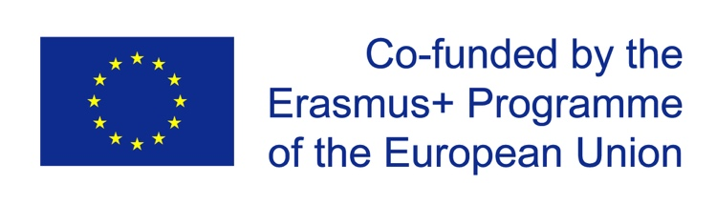 | Development of Skills and  Teachers Training for leadership | 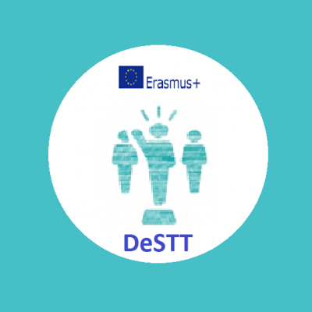

DeSTT - Development of Skills and Teachers Training for leadership
Registration Number of the Project: 609905-EPP-1-2019-1-IT-EPPKA2-CBHE-JP

Project duration: January 15, 2020-January 14, 2023
The project is aimed at developing and modernizing formal and informal educational programs in the field of professional development and teachers training in Mongolia, Kazakhstan and Russia in order to expand the opportunities of teachers with insufficient leadership competencies. As well as creating an educational leadership center as a platform for the design, development and promotion of socially significant ideas of the pedagogical community in the region.
Official Website of the Project: www.destt.info
Project Page on Facebook: https://www.facebook.com/Destt.20/
The DeSTT project leaflet is in Kazakh, English, Russian.

Project Coordinator: University of Cassino and Southern Lazio (Italy)

Project Consortium Members:
- Fondazione Sicurezza e Libertà (Italy)
- University of Social Sciences (Poland)
- University of Santiago de Compostela (Spain)
- Yaroslav-The-Wise Novgorod State University (Russia)
- Irkutsk State Agrarian University (Russia)
- University of International Business (Kazakhstan)
- M. Kozybayev North-Kazakhstan State University (Kazakhstan)
- Mongolian National University of Education (Mongolia)
- Mongolian University of Science and Technology (Mongolia)
- Mongolian University of Life Sciences (Mongolia)

Aims and specific objectives:

The project consortium will transfer knowledge and experiences from EU country to the others to understand the differences of the eligible countries (Russia, Kazakhstan and Mongolia). The countries share the same challenges in training teachers for leadership and should share common solutions. The variety of countries becomes an added value in a global system.

Innovative interdisciplinary module cluster for 2nd cycle of higher education will integrate formal and informal education approaches, ICT methodologies to training teachers for leadership and will promote practice-oriented skills learning. Multidisciplinary curriculum will be created (Master MA 1 year 30 ECTS) and it will combine pedagogical, psychological, sociological, educational law, economics and human resource management modular elements.

The project meets the national and regional level priorities of Partner Countries in curriculum development in the field of education, information and communication technologies, business and administration, social and behavioural sciences.

In particular:

1. Developing Master program for training teachers in the formal system of education (MA 1 year 30 ECTS).

2. Developing programs for professional development of teachers for leadership in integrated formal and informal educational formats

3. Establishing Education Centres for Leadership as platforms for the design, development and promotion of socially significant ideas of the local community, for networking of educators with local community

