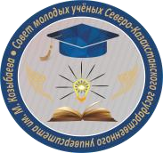
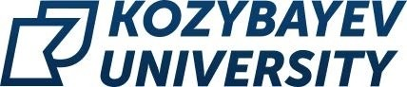

MINISTRY OF EDUCATION AND SCIENCE OF THE REPUBLIC OF KAZAKHSTAN
M. KOZYBAYEV NORTH KAZAKHSTAN UNIVERSITY

INFORMATION LETTER

Dear students!

The Council of Young Scientists of Kozybayev University holds a video contest "My research activity at the university" among undergraduate students of 1-4 courses of all faculties.
The purpose of the competition is to popularize scientific knowledge and motivate students to participate in research work.
The winners will be announced according to the results of the competition. I place is awarded with a cash prize in the amount of 50,000 tenge, II place - in the amount of 30,000 tenge, III place - in the amount of 20,000 tenge. All contestants will receive certificates of participants.
In the video, the student must present the results (final or intermediate) of his university research activities.
The evaluation of the works will take into account the compliance with the purpose of the Competition; the content and integrity of the material presented; the reasonableness and validity of one's own point of view on the problem under consideration; the manifestation of creative and independent thinking; the originality of the idea and creative approach to the disclosure of the topic; the quality of the design of the work; the scientific component (scientific and economic novelty, practical significance of the object of research); the relevance of the research within the region and the Republic of Kazakhstan.
Technical characteristics of the video file:
- aspect ratio 16:9;
- videos must be added in the highest resolution and the best quality with a duration of 3 to 5 minutes;
- file format: mpeg-4/mov/avi/mpeg-2;
- audio codec: MPEG Layer II or Dolby AC-3;
- audio bitrate: 128 Kbit/s or higher;
- video codec: XviD, H.264;
- video bitrate: 1024 Kbit/s or higher.
The Competition work and application must be sent to the mailing address of the Council of Young Scientists f the Council of Young Scientists: smu@nku.edu.kz no later than December 1. It is acceptable to use external links to third-party resources. The winners will be awarded on December 10 with the presentation of diplomas and cash certificates.
Works submitted later than the specified deadline or executed not in accordance with the requirements are not considered.
For any additional questions, please call 87055698255 Petrov Pavel Anatolyevich, Chairman of the YSC.

The Council of Young Scientists of M. Kozybayev NKU
Appendix 1

Example of an application form for the competition

To the Chairman
of the video contest commission
"My research activity
at the university
To Petrov P.A.
"Name of the contestant
(in full,
in the genitive case)"

Application

I would like you to include my video work for participation in the video contest «My research activity in the university».
Information about the contestant and the work:

Name of the contestant
Email address
Contact phone number
Faculty, study group
text description of the video (no more than 1000 characters)

Signature, date

