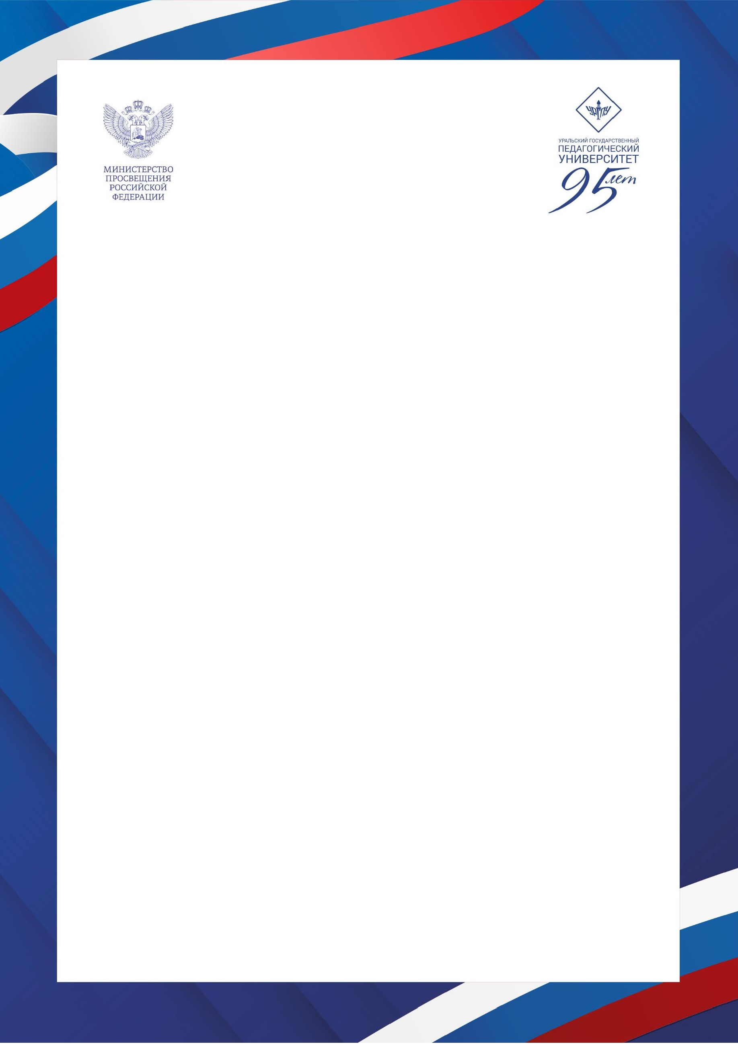

International Scientific and Practical Conference
RUSSIA AND THE WORLD:
EDUCATION. CULTURE. HISTORY. VALUES
February 17 – 20, 2026
Yekaterinburg, Russia

Conference objectives: discussion of current topics in intercultural communication, scientific and educational collaboration between Russia and foreign countries, the training of educators in the global context, and the development of values as a cultural identity code.
ORGANIZERS

- Ural State Pedagogical University
- Scientific Center of the Russian Academy of Education at USPU

DIRECTIONS OF THE CONFERENCE

Pedagogical education in the modern world: comparative aspect
- The problems faced by people with limited health capabilities and disabilities in the international education sector.
- Implementation of an evidence-based approach in domestic and foreign education.
- Features of teacher training: domestic and foreign experience.

Education as a cultural identity code of an individual
- Family values as the basis of an individual's cultural code;
- Value guidelines for the professional training of future teachers in the global educational space.

International cooperation: History. Education. Geopolitics
- Historical memory in the CIS countries;
- Russia-Asia: scientific and educational cooperation.

Conference format: online and offline.

CONTACT INFORMATION
Doctor Alyona Postnikova, Director of the Scientific Center of the RAE, Ural State Pedagogical University, +7 982 6891667, alyonapostnikova87@yandex.ru

Applications for participation are accepted until February 1, 2026.
https://forms.yandex.ru/u/6964adca50569082d1902a10





